Apply filters to SQL queries

Project description
[I will be accomplishing 6 different tasks that involve filtering with SQL that deal with real world possible scenarios in Cybersecurity. The filters I will work with are where, and, or, like, and not.]

Retrieve after hours failed login attempts
[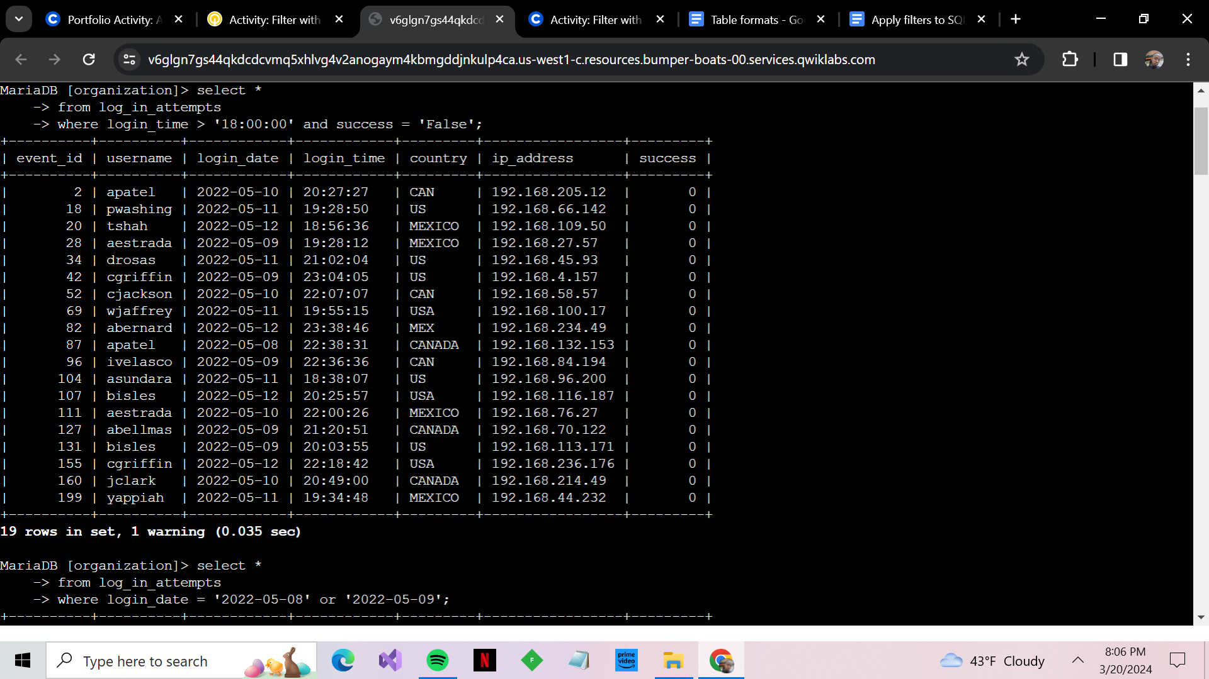The screenshot you see filtering of two separate columns with the where filter along with and. I was able to not only filter for time of login attempts but also combine failed attempts to see any suspicious activity.]

Retrieve login attempts on specific dates
[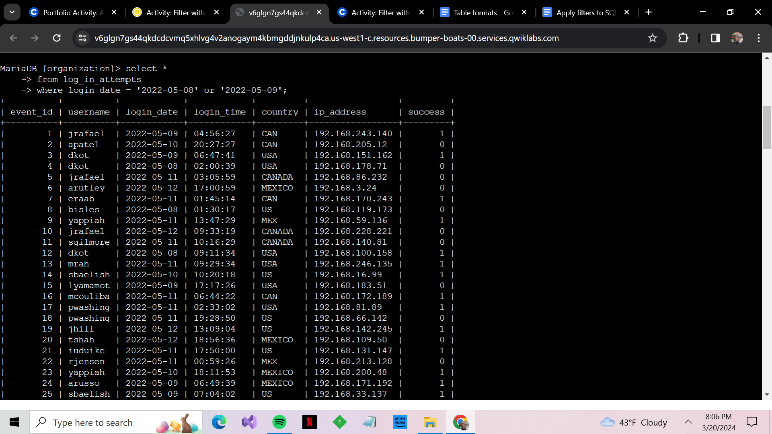The screenshot shows how I was able to retrieve two different dates to be filtered as I used where, and or filters. That allowed me to see any suspicious activity that was alerted on those two days.]

Retrieve login attempts outside of Mexico
[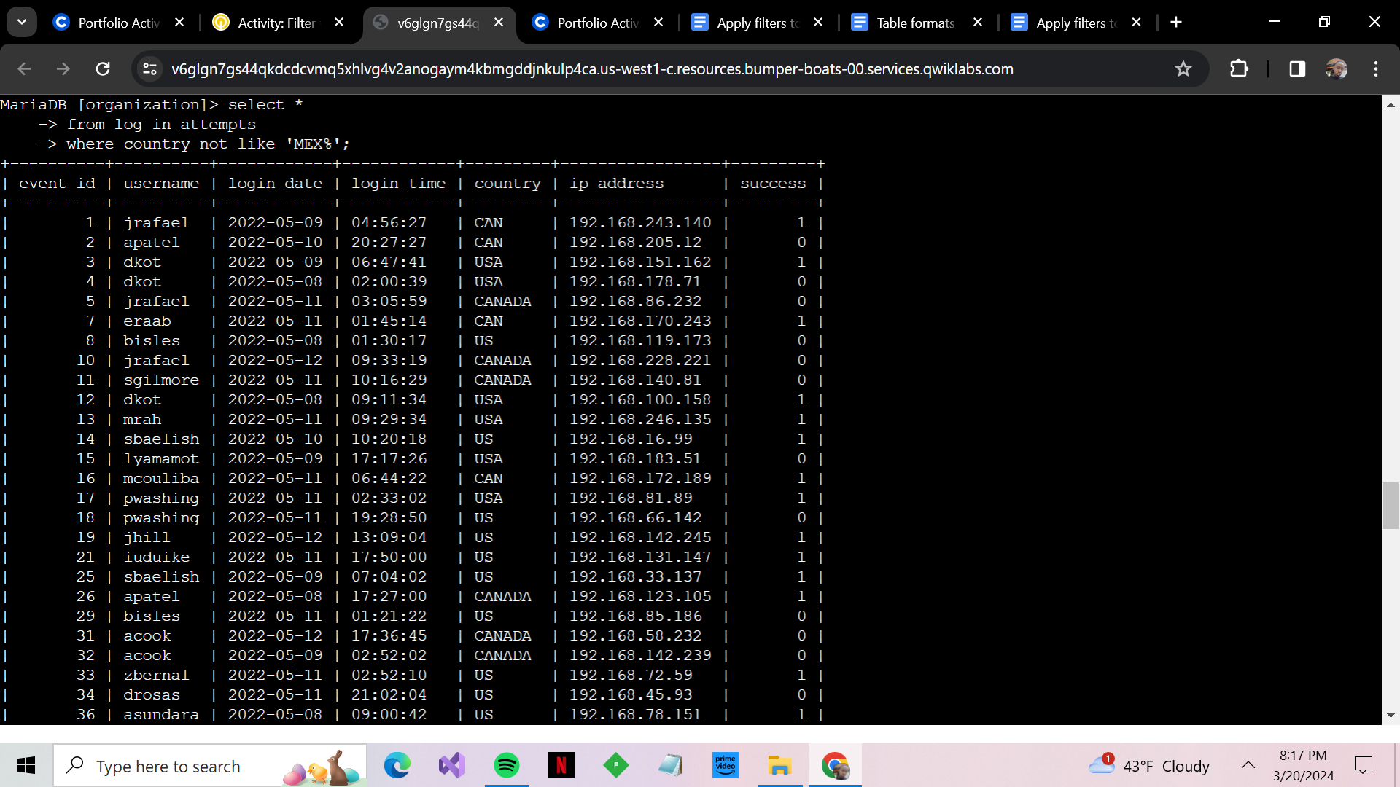The screenshot shows how I was able to filter for every state except Mexico by using the where and not filter. This allowed me to check for suspicious activity in other countries that has popped up in the alert.]

Retrieve employees in Marketing
[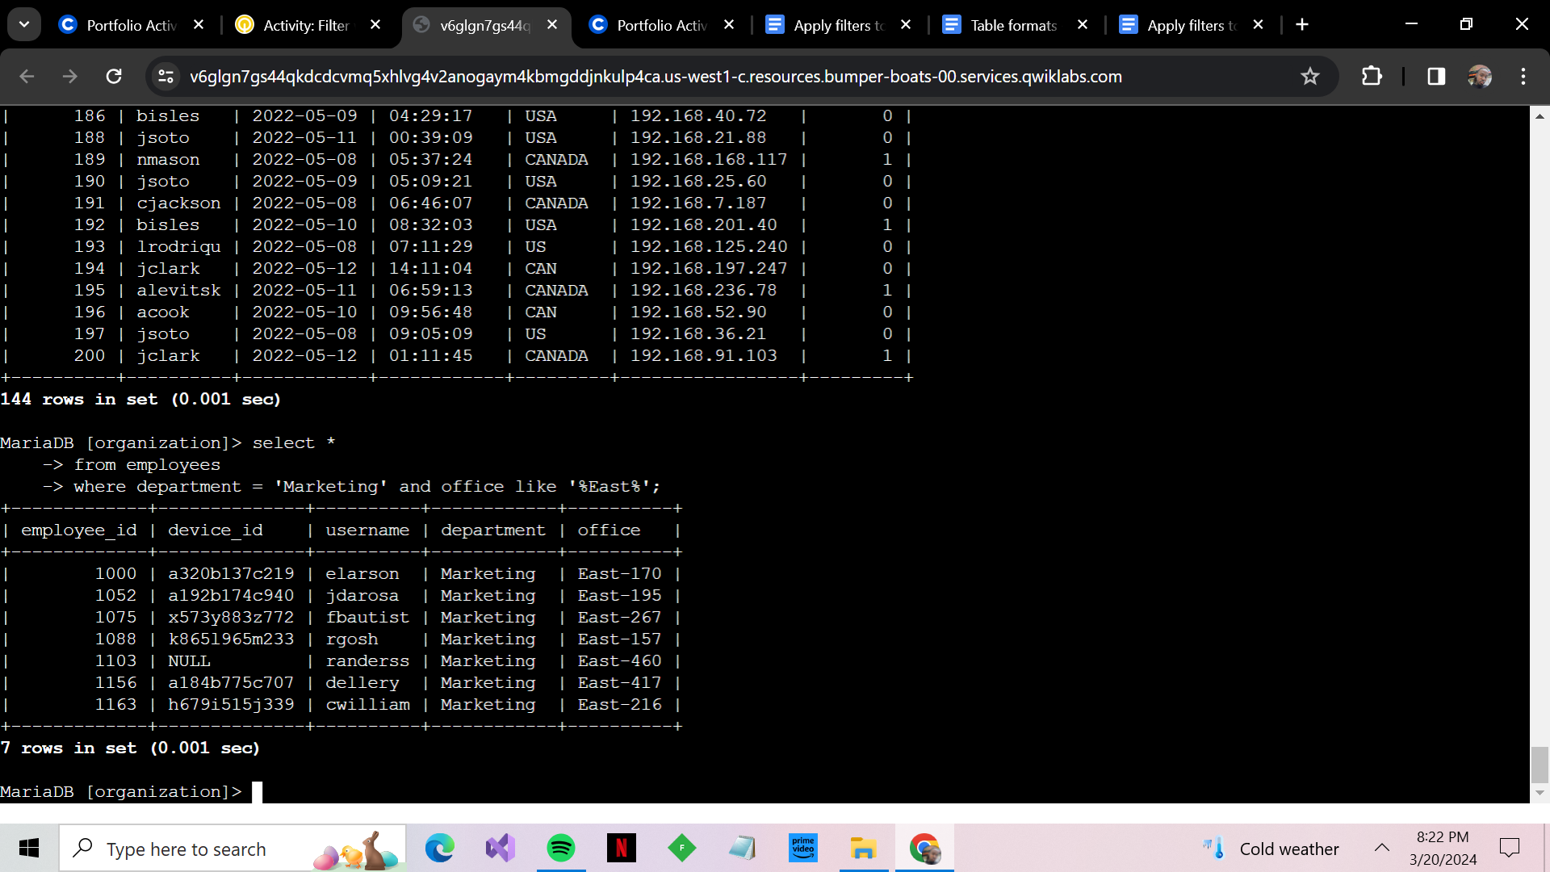The screenshot shows how I retrieved all employees from marketing by using the where filter in SQL along with the like filter to query exactly what I want using the wildcard %%. The query now helps me see who needs updates.]

Retrieve employees in Finance or Sales
[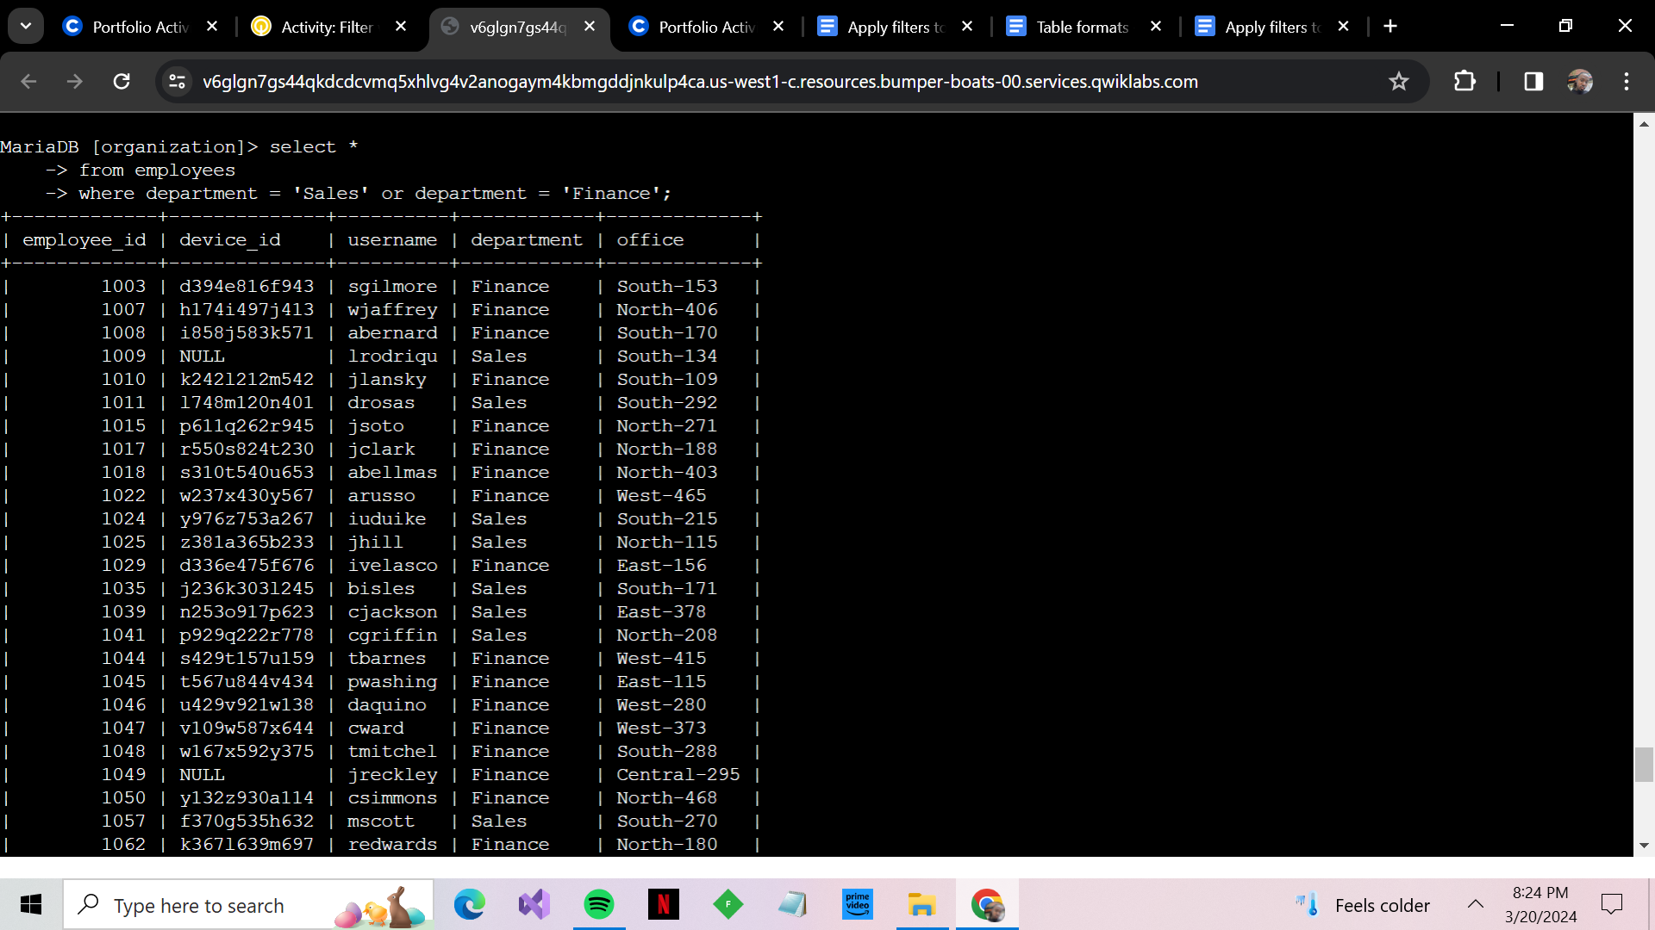The screenshot shows how I was able to filter sales along with the finance department by using the where and or filter in SQL. The query now is able to help me see who needs updates for their machines.]

Retrieve all employees not in IT
[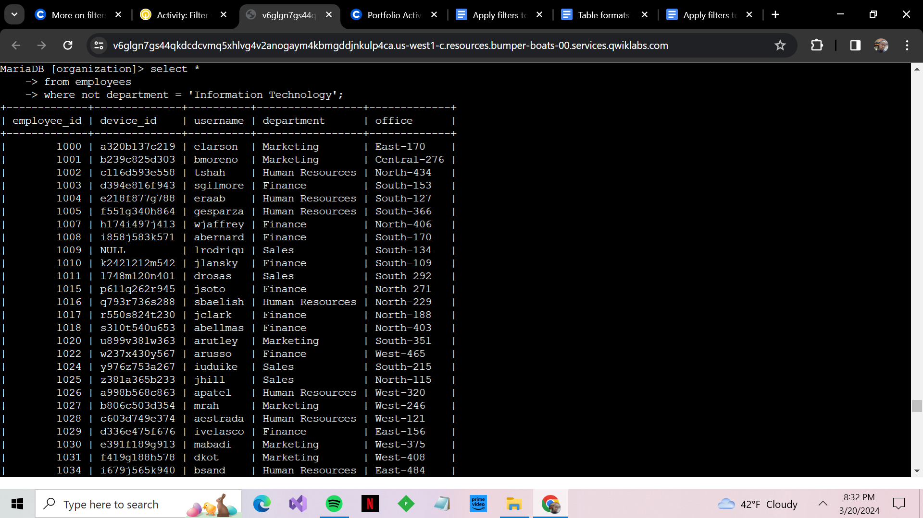The screenshot shows how I was able to use another not filter along with where in order to get every department that was not a part of the IT department to filter out. The query now helps me see every employee except the IT department that needs an update for their machines.]

Summary
[In conclusion this is how I used my SQL filtering skills to tackle similar alerts and incidents that are in the cybersecurity field. The and, where, like, not, and lastly or are very powerful in helping me write less SQL queries and take what could have been two queries or more and turn it into one.]

